File 4: Stored procedure

Database Creation:

CREATE DATABASE EmployeeManagementSystem;
GO

USE EmployeeManagementSystem;
GO

CREATE TABLE Departments (
DepartmentID INT PRIMARY KEY,
DepartmentName VARCHAR(100)
);
GO

CREATE TABLE Employees (
EmployeeID INT PRIMARY KEY,
FirstName VARCHAR(50),
LastName VARCHAR(50),
DepartmentID INT FOREIGN KEY REFERENCES Departments(DepartmentID),
Salary DECIMAL(10,2),
JoinDate DATE
);
GO

INSERT INTO Departments (DepartmentID, DepartmentName) VALUES
(1, 'HR'),
(2, 'Finance'),
(3, 'IT'),
(4, 'Marketing');
GO

INSERT INTO Employees (EmployeeID, FirstName, LastName, DepartmentID, Salary, JoinDate) VALUES
(1, 'John', 'Doe', 1, 5000.00, '2020-01-15'),
(2, 'Jane', 'Smith', 2, 6000.00, '2019-03-22'),
(3, 'Michael', 'Johnson', 3, 7000.00, '2018-07-30'),
(4, 'Emily', 'Davis', 4, 5500.00, '2021-11-05'),
(5, 'Robert', 'Wilson', 1, 4800.00, '2020-05-12'),
(6, 'Sarah', 'Brown', 2, 6200.00, '2019-08-14'),
(7, 'David', 'Miller', 3, 7500.00, '2018-12-01'),
(8, 'Lisa', 'Anderson', 1, 5200.00, '2021-02-28'),
(9, 'Kevin', 'Taylor', 3, 6800.00, '2020-09-15'),
(10, 'Maria', 'Garcia', 4, 5800.00, '2021-06-10');
GO

Exercise-01: Create a Stored Procedure

- Code:

Use EmployeeManagementSystem;
GO

PRINT 'Creating Exercise 1 stored procedures...';

IF OBJECT_ID('sp_GetEmployeesByDepartment', 'P') IS NOT NULL
DROP PROCEDURE sp_GetEmployeesByDepartment;
GO

IF OBJECT_ID('sp_InsertEmployee', 'P') IS NOT NULL
DROP PROCEDURE sp_InsertEmployee;
GO

CREATE PROCEDURE sp_GetEmployeesByDepartment
@DepartmentID INT
AS
BEGIN
SET NOCOUNT ON;

-- Validate input
IF @DepartmentID IS NULL
BEGIN
RAISERROR('DepartmentID cannot be NULL', 16, 1);
RETURN;
END

-- Check if department exists
IF NOT EXISTS (SELECT 1 FROM Departments WHERE DepartmentID = @DepartmentID)
BEGIN
RAISERROR('Department with ID %d does not exist', 16, 1, @DepartmentID);
RETURN;
END

-- Return employee details
SELECT
e.EmployeeID,
e.FirstName,
e.LastName,
e.DepartmentID,
d.DepartmentName,
e.Salary,
e.JoinDate
FROM Employees e
INNER JOIN Departments d ON e.DepartmentID = d.DepartmentID
WHERE e.DepartmentID = @DepartmentID
ORDER BY e.LastName, e.FirstName;
END;
GO

-- Create sp_InsertEmployee
CREATE PROCEDURE sp_InsertEmployee
@FirstName VARCHAR(50),
@LastName VARCHAR(50),
@DepartmentID INT,
@Salary DECIMAL(10,2),
@JoinDate DATE
AS
BEGIN
-- Validate department exists
IF NOT EXISTS (SELECT 1 FROM Departments WHERE DepartmentID = @DepartmentID)
BEGIN
RAISERROR('Department with ID %d does not exist', 16, 1, @DepartmentID);
RETURN;
END

-- Get next available EmployeeID
DECLARE @NextEmployeeID INT;
SELECT @NextEmployeeID = ISNULL(MAX(EmployeeID), 0) + 1 FROM Employees;

-- Insert new employee
INSERT INTO Employees (EmployeeID, FirstName, LastName, DepartmentID, Salary, JoinDate)
VALUES (@NextEmployeeID, @FirstName, @LastName, @DepartmentID, @Salary, @JoinDate);
END;
GO
PRINT 'Stored procedures created successfully';
- Output:

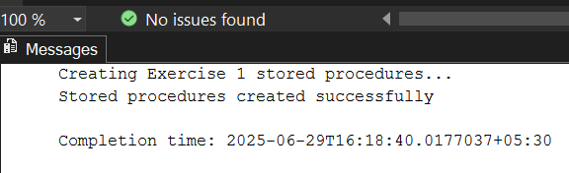

Exercise 4: Execute a Stored Procedure

- Code:

USE EmployeeManagementSystem;
GO

PRINT '=== EXECUTING STORED PROCEDURES ===';
PRINT '';

IF OBJECT_ID('sp_GetEmployeesByDepartment', 'P') IS NULL
BEGIN
PRINT 'ERROR: sp_GetEmployeesByDepartment procedure does not exist!';
PRINT 'Please run Exercise 1 solution first to create the stored procedure.';
RETURN;
END
ELSE
PRINT 'sp_GetEmployeesByDepartment procedure found - Ready to execute';

PRINT '';

-- Execute for HR Department (DepartmentID = 1)
PRINT '--- Executing sp_GetEmployeesByDepartment for HR Department (ID: 1) ---';
EXEC sp_GetEmployeesByDepartment @DepartmentID = 1;

PRINT '';

-- Execute for Finance Department (DepartmentID = 2)
PRINT '--- Executing sp_GetEmployeesByDepartment for Finance Department (ID: 2) ---';
EXEC sp_GetEmployeesByDepartment @DepartmentID = 2;

PRINT '';

-- Execute for IT Department (DepartmentID = 3)
PRINT '--- Executing sp_GetEmployeesByDepartment for IT Department (ID: 3) ---';
EXEC sp_GetEmployeesByDepartment @DepartmentID = 3;

PRINT '';

-- Execute for Marketing Department (DepartmentID = 4)
PRINT '--- Executing sp_GetEmployeesByDepartment for Marketing Department (ID: 4) ---';
EXEC sp_GetEmployeesByDepartment @DepartmentID = 4;

PRINT '';
PRINT '--- Alternative Execution Methods ---';
PRINT 'Method 1 - Using positional parameter for IT Department:';
EXEC sp_GetEmployeesByDepartment 3;

PRINT '';

PRINT 'Method 2 - Using EXECUTE keyword for HR Department:';
EXECUTE sp_GetEmployeesByDepartment @DepartmentID = 1;

PRINT '';

PRINT 'Method 3 - Dynamic execution based on department name:';

-- Get department ID for 'Finance' and execute
DECLARE @DeptID INT;
SELECT @DeptID = DepartmentID FROM Departments WHERE DepartmentName = 'Finance';

PRINT 'Executing for Finance Department (Dynamic ID lookup):';
EXEC sp_GetEmployeesByDepartment @DepartmentID = @DeptID;

PRINT '';

-- Test with invalid department ID
PRINT 'Testing with invalid Department ID (999):';
BEGIN TRY
EXEC sp_GetEmployeesByDepartment @DepartmentID = 999;
END TRY
BEGIN CATCH
PRINT 'Error caught: ' + ERROR_MESSAGE();
END CATCH

PRINT '';

-- Test with NULL parameter
PRINT 'Testing with NULL parameter:';
BEGIN TRY
EXEC sp_GetEmployeesByDepartment @DepartmentID = NULL;
END TRY
BEGIN CATCH
PRINT 'Error caught: ' + ERROR_MESSAGE();
END CATCH

PRINT '';

PRINT '--- Verification: Count of Results per Department ---';

-- Count employees returned by each department execution
SELECT
'HR' AS Department,
COUNT(*) AS EmployeeCount
FROM Employees
WHERE DepartmentID = 1

UNION ALL

SELECT
'Finance' AS Department,
COUNT(*) AS EmployeeCount
FROM Employees
WHERE DepartmentID = 2

UNION ALL

SELECT
'IT' AS Department,
COUNT(*) AS EmployeeCount
FROM Employees
WHERE DepartmentID = 3

UNION ALL

SELECT
'Marketing' AS Department,
COUNT(*) AS EmployeeCount
FROM Employees
WHERE DepartmentID = 4;

PRINT '';

PRINT '--- Advanced Usage: Capturing and Analyzing Results ---';

-- Create a temporary table to store results
IF OBJECT_ID('tempdb..#TempEmployeeResults') IS NOT NULL
DROP TABLE #TempEmployeeResults;

CREATE TABLE #TempEmployeeResults (
EmployeeID INT,
FirstName VARCHAR(50),
LastName VARCHAR(50),
DepartmentID INT,
DepartmentName VARCHAR(100),
Salary DECIMAL(10,2),
JoinDate DATE
);

-- Insert results from stored procedure into temp table
INSERT INTO #TempEmployeeResults
EXEC sp_GetEmployeesByDepartment @DepartmentID = 3;

-- Analyze the captured results
PRINT 'Analysis of IT Department employees (captured from stored procedure):';
SELECT
COUNT(*) AS TotalEmployees,
AVG(Salary) AS AverageSalary,
MIN(JoinDate) AS EarliestJoinDate,
MAX(JoinDate) AS LatestJoinDate
FROM #TempEmployeeResults;

-- Show the captured data
SELECT 'Captured Employee Data:' AS Info;
SELECT * FROM #TempEmployeeResults ORDER BY LastName;

-- Clean up
DROP TABLE #TempEmployeeResults;
PRINT '';
PRINT 'All stored procedure executions completed with results reviewed.';
-- Summary Report
PRINT '';
PRINT '--- SUMMARY REPORT ---';
SELECT
d.DepartmentName,
COUNT(e.EmployeeID) AS TotalEmployees,
'EXEC sp_GetEmployeesByDepartment @DepartmentID = ' + CAST(d.DepartmentID AS VARCHAR(5)) AS ExecutionCommand
FROM Departments d
LEFT JOIN Employees e ON d.DepartmentID = e.DepartmentID
GROUP BY d.DepartmentID, d.DepartmentName
ORDER BY d.DepartmentID;

Output:

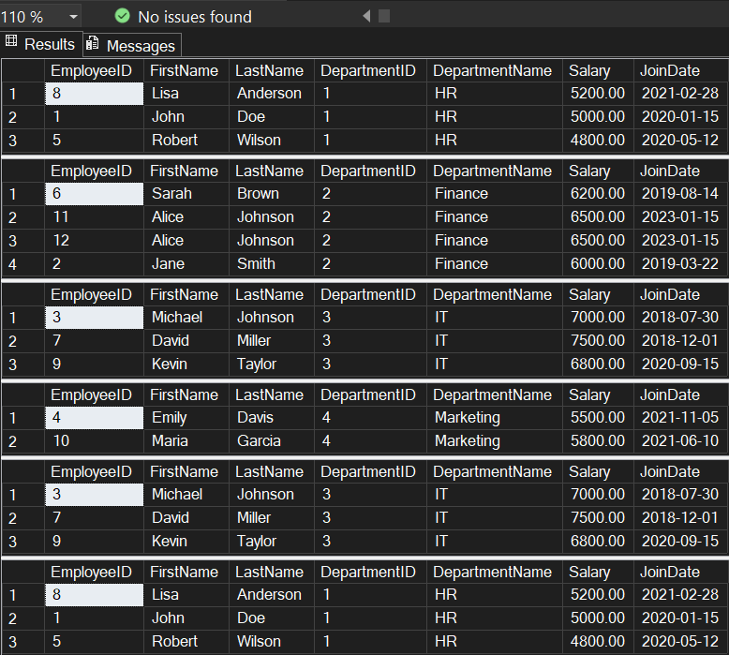
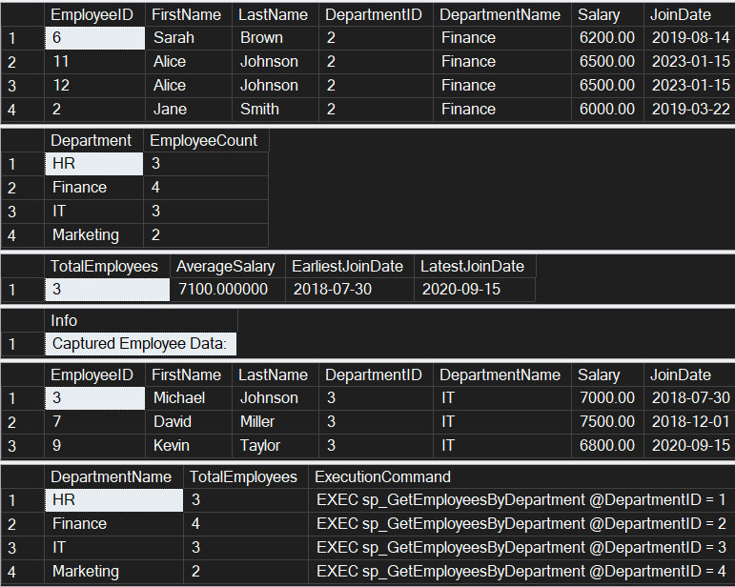

Exercise 5: Return Data from a Stored Procedure

- Code:

Use EmployeeManagementSystem;
GO

PRINT 'Creating Exercise 5 Stored Procedure...';

IF OBJECT_ID('sp_GetEmployeeCountByDepartment', 'P') IS NOT NULL
DROP PROCEDURE sp_GetEmployeeCountByDepartment;
GO

-- Create stored procedure that returns the total number of employees in a department
CREATE PROCEDURE sp_GetEmployeeCountByDepartment
@DepartmentID INT
AS
BEGIN
SET NOCOUNT ON;

-- Validate input parameter
IF @DepartmentID IS NULL
BEGIN
PRINT 'Error: DepartmentID cannot be NULL';
RETURN;
END

-- Check if department exists
IF NOT EXISTS (SELECT 1 FROM Departments WHERE DepartmentID = @DepartmentID)
BEGIN
PRINT 'Error: Department with ID ' + CAST(@DepartmentID AS VARCHAR(10)) + ' does not exist';
RETURN;
END

-- Declare variables for department info
DECLARE @DepartmentName VARCHAR(100);
DECLARE @EmployeeCount INT;

-- Get department name
SELECT @DepartmentName = DepartmentName
FROM Departments
WHERE DepartmentID = @DepartmentID;

-- Count employees in the specified department
SELECT @EmployeeCount = COUNT(*)
FROM Employees
WHERE DepartmentID = @DepartmentID;

-- Return the count as a result set
SELECT
@DepartmentID AS DepartmentID,
@DepartmentName AS DepartmentName,
@EmployeeCount AS TotalEmployees;

-- Also return individual employee details for reference
SELECT
'Employee Details:' AS Info,
e.EmployeeID,
e.FirstName + ' ' + e.LastName AS FullName,
e.Salary,
e.JoinDate
FROM Employees e
WHERE e.DepartmentID = @DepartmentID
ORDER BY e.LastName, e.FirstName;
-- Print summary message
PRINT 'Department: ' + @DepartmentName + ' has ' + CAST(@EmployeeCount AS VARCHAR(10)) + ' employees';
END;
GO

PRINT 'Exercise 5 stored procedure created successfully!';

-- TESTING THE STORED PROCEDURES
PRINT '=== TESTING EXERCISE 1 STORED PROCEDURES ===';

-- Test sp_GetEmployeesByDepartment
PRINT 'Testing sp_GetEmployeesByDepartment for HR Department (ID: 1):';
EXEC sp_GetEmployeesByDepartment @DepartmentID = 1;

PRINT '';
PRINT 'Testing sp_GetEmployeesByDepartment for IT Department (ID: 3):';
EXEC sp_GetEmployeesByDepartment @DepartmentID = 3;

PRINT '';
PRINT 'Testing sp_InsertEmployee - Adding a new employee:';
EXEC sp_InsertEmployee
@FirstName = 'Alice',
@LastName = 'Johnson',
@DepartmentID = 2,
@Salary = 6500.00,
@JoinDate = '2023-01-15';

PRINT '';
PRINT '=== TESTING EXERCISE 5 STORED PROCEDURE ===';

-- Test sp_GetEmployeeCountByDepartment for each department
PRINT 'Testing sp_GetEmployeeCountByDepartment for HR Department (ID: 1):';
EXEC sp_GetEmployeeCountByDepartment @DepartmentID = 1;

PRINT '';
PRINT 'Testing sp_GetEmployeeCountByDepartment for Finance Department (ID: 2):';
EXEC sp_GetEmployeeCountByDepartment @DepartmentID = 2;

PRINT '';
PRINT 'Testing sp_GetEmployeeCountByDepartment for IT Department (ID: 3):';
EXEC sp_GetEmployeeCountByDepartment @DepartmentID = 3;

PRINT '';
PRINT 'Testing sp_GetEmployeeCountByDepartment for Marketing Department (ID: 4):';
EXEC sp_GetEmployeeCountByDepartment @DepartmentID = 4;

-- ERROR TESTING

PRINT '';
PRINT '=== ERROR TESTING ===';

PRINT 'Testing with invalid department ID (999):';
EXEC sp_GetEmployeesByDepartment @DepartmentID = 999;

PRINT '';
PRINT 'Testing employee count with invalid department ID (999):';
EXEC sp_GetEmployeeCountByDepartment @DepartmentID = 999;

-- SUMMARY REPORT
PRINT '';
PRINT '=== FINAL SUMMARY ===';

SELECT 'DEPARTMENT SUMMARY:' AS ReportType;
SELECT
d.DepartmentID,
d.DepartmentName,
COUNT(e.EmployeeID) AS TotalEmployees,
AVG(e.Salary) AS AverageSalary,
MIN(e.Salary) AS MinSalary,
MAX(e.Salary) AS MaxSalary,
SUM(e.Salary) AS TotalSalaryBudget
FROM Departments d
LEFT JOIN Employees e ON d.DepartmentID = e.DepartmentID
GROUP BY d.DepartmentID, d.DepartmentName
ORDER BY d.DepartmentID;

- Output:

